1. 安裝JDK, Eclipse(STS)

JDK 🡺 jdk-8u191-windows-x64

Eclipse(STS) 🡺 sts-4.6.1.RELEASE.zip

<https://download.springsource.com/release/STS4/4.6.1.RELEASE/dist/e4.15/spring-tool-suite-4-4.6.1.RELEASE-e4.15.0-win32.win32.x86_64.zip>

1. 安裝gradle5.6.3， https://services.gradle.org/distributions/gradle-5.6.3-bin.zip

解壓縮於D:\ gradle-5.6.3

1. 建立本機gradle lib下載目錄, D:\GradleHome
2. 設定環境變數GRADLE_USER_HOME=D:\GradleHome
3. 解壓縮common.zip放在D:/GradleHome/libs
4. 匯入gradle官方網站憑證，參考
5. 開啟Eclipse(STS)設定gradle

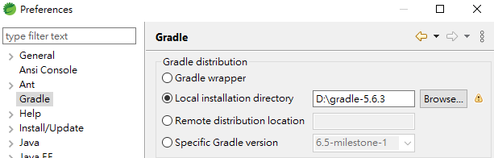

1. 設定文字編碼

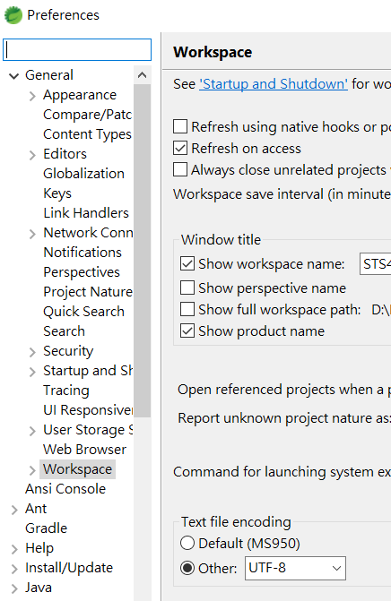

1. 安裝mybatis plugin

下載站台: <http://dl.bintray.com/mybatis/mybatis-generator>

